May 3rd, 2009
Hi
Well, a lot can happen in one week. It is only a week ago that I wrote the first entry in my diary about swine flu. Now it has spread from Mexico to many countries around the world. On Friday, the first case of swine flu in HK was confirmed. It was a Mexican man who arrived the day before on a flight from Mexico via Shanghai. At both Shanghai and HK airports, he was not picked up as having a temperature. I was reading that such screening is probably useless because by the time a person has a fever, the infectious stage has already passed. Anyway, he checked in at a hotel in Wanchai, and, would you believe it, this hotel is owned by the same company than owns the hotel where the first person to have SARS was detected in 2003! The guy felt ill so took a taxi to a hotel which tested him and the results for the flu came back positive. The government raised the local alert level to ‘emergency’, which gives it greater powers to act. The guy was quarantined in a hospital. In addition, the hotel, with all its 350 guests and staff, has been quarantined for a week. Some, who did not want to stay in the hotel were moved to the Lady Maclehose holiday site in Sai Kung (a place some of you have stay at, I think). Many of the guests are not too happy about it. Some guests, who were out when the hotel was quarantined, decided not to re-enter when they returned as they were told that if they did so, they would not be allowed out again. HK learnt a lot from the SARS outbreak fiasco, when 299 people died. The current WHO director, Margaret Chan, was the Director of Health in HK at the time and was severely criticised over her handling on the epidemic.

No run yesterday. The running season is over. It is too hot for me to run in the very hot and humid summer. So just gym work and swimming. I went for another three swims this past week. The pattern is to go to the gym first for a 15-min treadmill run and 8-10 min row then to the pool. (It used to be skipping instead of rowing but I have not done any skipping for a while now.) This week, the gym is supposed to be getting two new treadmills. Until about six months ago, it used to have four, but then two were damaged beyond repair and then a week or so ago, another broke down. So, only one! The treadmills are the most popular item in the gym and there have been many complaints about having only two, and now only one. Because of this, they limited use of the treadmills to a maximum of 30 minutes.
Some time ago, I mentioned the bus terminal rooftop garden below my window that was completed but not open. This past the lights came on for first time and are on all night, though they do not affect the suite much.
On Friday, an R-22 helicopter crashed into bus near the HK flying club, which is still based at the old Kai Tak airport site. Just three injuries – the two in the helicopter and a mechanic in the bus. I mentioned that an R-44 helicopter crashed in Sai Kung several years ago. Both crashed for the same reason – gusty conditions. An expert said that this is a deficiency in Robinson helicopters. There is something called a T-bar (? T-control) which must be handled very gently in windy conditions to keep the helicopter stable. Comments Gavin?

Did you hear that a two-year old UK girl has become the youngest member of Mensa?
Yesterday was the bun festival on Cheung Chau Island. The actual scramble up the bun towers is held at midnight (I think). Now, they have pre-festival competitions to select those who will be allowed to participate in the climb. This now includes women, though both the men and the women are a bit unhappy, as the women are not as fast as the men, which results in a lot of interference. In addition, climbers must now use climbing gear to prevent them from falling. Until a few years ago, it was a free-for-all with anybody allowed to climb the towers. This, of course, resulted in falls and serious injuries. Also, the buns on the towers are now made of plastic, which adds to the safety. (The buns sold for eating are, of course, real.) I’m not completely sure of the point of the climb, but it seems to include who can get to the top first (and possibly to get the buns at the top) as well as who can collect the most buns (which they put into a bag they carry). As well as climbing the bun towers, there is also a parade, which includes young children suspended (comfortably) on poles. The pictures below are from last year, as this year’s pictures are not yet available.
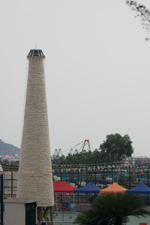

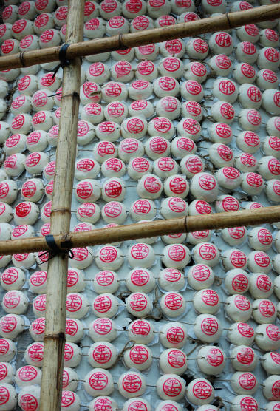
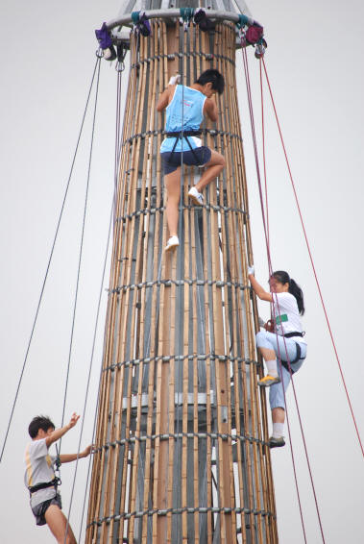
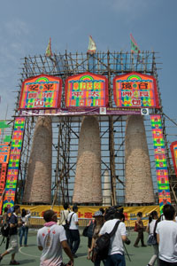
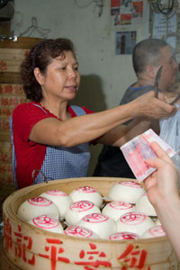
That’s it for now.
Cheers

